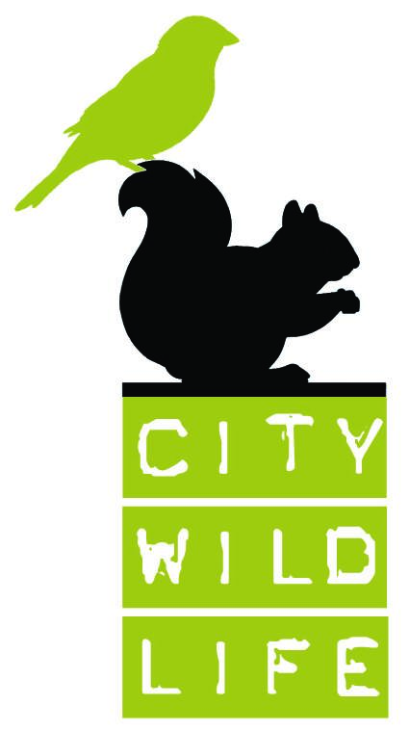**City Wildlife Internship Application**

**Name:**

**Address:**

**Phone Number:**

**Email Address:**

**Date of Birth:**

1. Please give a brief description of what City Wildlife does and what this internship entails.

2. What experience do you have working with animals?

3. What strengths do you have that will assist you in this internship?

4. What challenges may present themselves during the internship?

5. What are you hoping to gain from this internship experience?

6. Are you able to commit to 8-12 weeks of unpaid work?

7. Interns are scheduled 3-4 days per week at 8 hours a shift. Are you able to commit to this?

8. Please give the day you could start on and your timeframe of availability.

9. Are there any species of wildlife you already know you are **not** comfortable working with?

10. Are you comfortable with euthanasia and being exposed to deceased animals?

11. What would your commute be like?

12. Do you have a favorite animal and why?

**References** -Please provide contact information for two references

|  |  |
| --- | --- |
| Name: |  |
| Relationship: |  |
| Years Known: |  |
| Organization: |  |
| Phone #: |  |
| Email: |  |

|  |  |
| --- | --- |
| Name: |  |
| Relationship: |  |
| Years Known: |  |
| Organization: |  |
| Phone #: |  |
| Email: |  |

Please return completed application with a resume, cover letter and proof of vaccination against COVID-19 to [info@citywildlife.org](mailto:info@citywildlife.org).

**This internship is hands-on and you can expect to be exposed to environmental allergens such as dust, feathers/fur, fecal matter, nuts, and latex on a daily basis. If you have any concerns about working with and around wildlife, please consult your doctor.**