**City Wildlife Volunteer Corps Application**

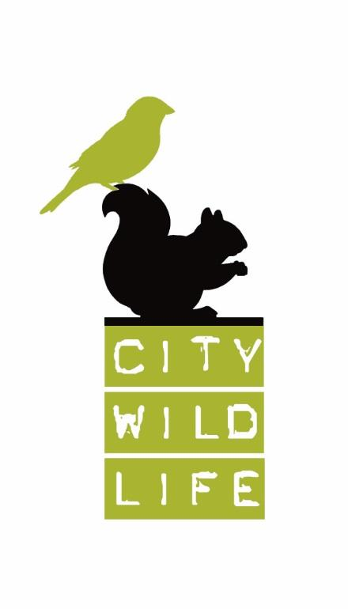Name:

Address:

Phone:

Email:

Emergency contact:

Their phone number:

Relationship:

How did you hear about City Wildlife?

What experiences are you seeking from your volunteer time at City Wildlife? Will this be for credit or other assignment?

Do you have any experience working with animals or in wildlife rehabilitation? If yes, please describe.

Please describe any other recent previous (or current) volunteer experiences you have had (with which organization, duties performed, for how long).

Volunteering at City Wildlife is hands-on. Do you have any physical limitations (bending, kneeling, lifting 20 pounds or more unassisted, standing for long periods, etc.) that we should be aware of? Any health concerns — such as allergies to dust, feathers/fur, fecal matter, nuts, and latex — or other health concerns that you would like City Wildlife to know about?

How do you feel about feeding dead rodents and birds or live insects to patients?

What are your thoughts about the common wildlife rehabilitation practice of humane euthanasia for patients with conditions beyond our means to treat, who would be unable to survive on their own in the wild?

Can and will you commit to working a regular, weekly, four-hour shift at City Wildlife through the summer months?

City Wildlife is not permitted to treat mice, rats, deer, bats, foxes, skunks, raccoons (or other rabies vector species), or domestic species of any kind including non-native/invasive species such as red-eared sliders. Are there any species of wildlife you are not comfortable working with or any that you particularly want to work with?

Do you speak any languages other than English?

We require all staff and volunteers to be fully vaccinated and boostered (as appropriate).

What days and times might you be available to volunteer at City Wildlife? Please indicate all that apply:

|  |  |  |  |  |  |  |
| --- | --- | --- | --- | --- | --- | --- |
| Sunday | Monday | Tuesday | Wednesday | Thursday | Friday | Saturday |
| a.m. | a.m. | a.m. | a.m. | a.m. | a.m. | a.m. |
| p.m. | p.m. | p.m. | p.m. | p.m. | p.m. | p.m. |

What concerns do you have about volunteering at City Wildlife?